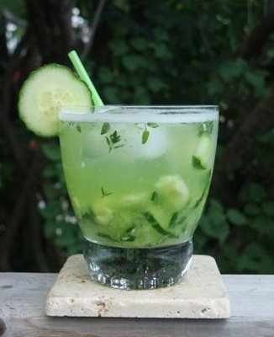

1.  Make your simple syrup.  It's super easy, and there is nothing to be frightened of here.  Combine equal parts sugar and water, bring to a boil, and cool.  I usually do 6 cups sugar and 6 cups water to make a good amount of syrup for a large batch of drinks.  Plus, simple syrup is always good to have on hand if you are into making any kind of cocktail that needs that extra touch of sweetness.

2.  Make your sour mix.  Most recipes call for equal parts fresh squeezed lemon juice, lime juice, and simple syrup.  But if you prefer one juice over the other, or simply have more God-damned limes than lemons, the recipe is very forgiving.  Just remember in the end that it's 2 parts juice to 1 part simple syrup.  I keep the sour mix in my fridge for up to a week or two, if it can last even THAT long.

3.  VERY Important.  Reserve some of your simple syrup for the cocktail itself.  OK, it's really not that important.  Yes it is.

Simple Syrup and Sour Mix

+

1. Roughly dice one slice of cucumber for each drink and place in bottom of glass.  I said rough!  No need for itsy bitsy tiny uniform pieces here.
2. Add a teaspoon of simple syrup and muddle the cucumber in the syrup.

"To muddle is to bring into a disordered or confusing state".

Aren't you glad you had rough pieces now?  Save your skill at creating uniformity for where it's really needed.

1. Add ice
2. Add 1/3 gin or vodka
3. Add 2/3 sour mix
4. Stir well to combine all the yummy ingredients and to get the drink good and cold
5. Add a few grinds of black peppercorns on top.  Let them float!  Your guests will be amazed.  Or possibly confused.
6. Garnish the side of the glass with a cucumber slice that has been precisely cut into 3/8 inch UNIFORM thickness and cut no more than 1/3 the way into the center of the round.  Any deviation may ruin the drink entirely.  OK, no it won't. Yes it will.
7. (my favorite part) ENJOY!

Footnote:  Karen Kidd suggested to me that rimming the class with a mix of salt and pepper prior to preparing the drink may be a good idea.  And why wouldn't it be?  Karen is the queen of recipe improvement, after all.

*You may submit comments regarding this recipe (as long as they are positive) to* [*ddexter224@icloud.com*](mailto:ddexter224@icloud.com).***Please drink responsibly.***

## And Now It’s Cocktail Time

Here is my recipe for the Cucumber Fresco Cocktail a la Scoozi Restaurant.  It makes for a great summer drink, and I have yet to meet someone who didn't love it.

You can use store-bought sour mix or make your own.  I prefer home-made, but I have found that Mr. & Mrs. T's sour mix from Jewel is pretty good, especially if lemons continue to be a buck a piece!

Dan Dexter

+

**Tools:**

rocks or double old fashioned glass

muddler*

knife and cutting board

spoon

**Ingredients:**

simple syrup

cucumber

ice

gin or vodka (I like Hendricks Gin, since it is flavored with cucumber)

sour mix

black peppercorns, freshly ground

*From Greg Beckett: In case you don't have one already, a muddler is a handy tool to have in your bar area.  The older ones look like miniature baseball bats.  There is a newer rendition made of stainless steel with a waffled end that helps grind/crush ingredients to be muddled.  Only $7.99 at Bed, Bath and Beyond (don't forget your 20% off coupon that they always send in the mail): <http://www.bedbathandbeyond.com/store/product/commercial-stainless-steel-muddler/1016344010>

- aliquam.

Cucumber Fresco Cocktail

Lorem ipsum dolor sit amet, consectetuer adipiscing elit.